
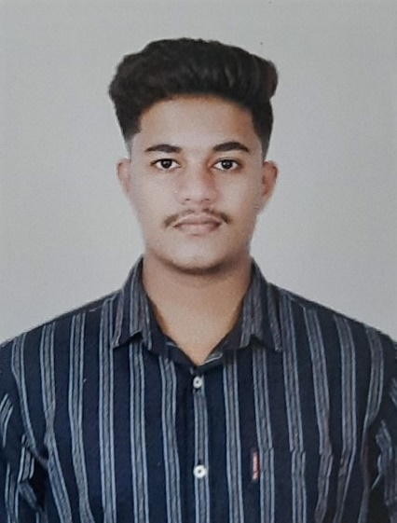


3113omkarphadtare@gmail.com
Objective:
" I am a Research Associate with a keen eye for data-driven insights. Expertise in gathering, analysing, and interpreting market trends. Proven track record in delivering actionable recommendations for strategic decision-making. Proficient in data analysis, utilizing advanced tools to extract meaningful patterns. Committed to driving business success through informed market strategies."
Playing Guitar
Cooking
Photography

Contact Details
OMKAR PHADTARE
PGDM in
(Marketing/Business Analytics)
Experience:
Market Research Analyst
MARTLENZ Knowledge Services · Full-time
October 2023 – September 2024
Pune, Maharashtra, India

Research Associate
MarketsandMarkets · Full-time
September 2024 - Present
Pune, Maharashtra, India
- Market Research & Analysis: Conduct primary and secondary research to gather quantitative and qualitative insights from key opinion leaders, industry experts, and market data sources.
- Market Forecasting & Competitive Intelligence: Perform market engineering, estimating, and forecasting global markets across America, EMEA, and APAC, while analysing competitive landscapes and identifying future market leaders.
- Strategic Business Insights: Develop entry strategies, assess product positioning, and analyse key market trends to provide actionable recommendations for business growth.
- Report Writing & Data Validation: Author analytical reports on industry trends, market dynamics, and key challenges, ensuring data accuracy and strategic insights.
- Client Relationship Management: Engage with clients to deliver high-value research and maintain relationships for repeat business opportunities.

Post Graduate Diploma in Management (PGDM) - Marketing and Business Analytics
[Indira Institute of Management], [Pune, Maharashtra]
[2021 – 2023]

Bachelor of [Business Administration] in [Marketing]
[Sinha gad college of science], [Pune, Maharashtra]
[2018 - 2021]
Education:
Hobbies
Marathi
English
Hindi
Languages
Communication Skills
Analytical Skills
Problem solving skills
MS-Excel
MS-Word
Power BI
Report Writing

Problem solving skills

Skills
Maharashtra, India
+91 8080088601

